Program 1
Improving Student Retention with Data-Driven Analysis
Algorithm / Procedure
- Collect student academic dataset.
- Identify key attributes:
  - Financial status
  - Attendance
  - GPA
- Calculate retention rate for each category.
- Compare retention patterns.
- Identify high-risk groups.
- Suggest improvement strategies.
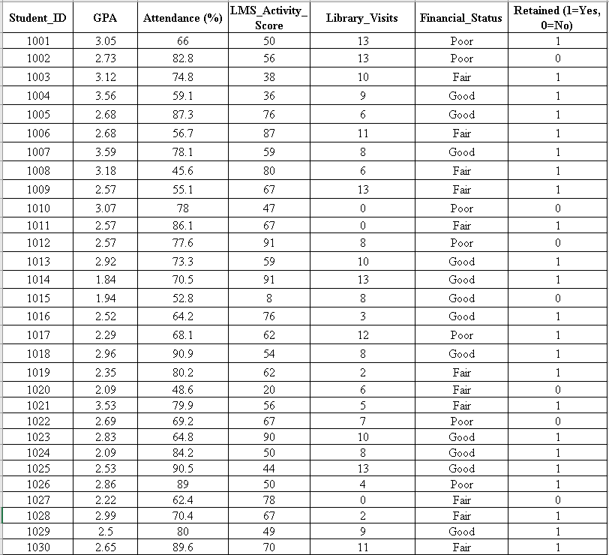

Financial_Status | Retention Rate
Good | 92%
Fair | 82%
Poor | 43%
Attendance Band | Retention Rate
<60% | 4
60-80% | 0
>80% | 8
Count Retained Students | 23
Count Total Students | 30
Retention Rate | 77%
GPA | Retention Rate
< 2.5 | 57%
2.5 - 3.5 | 81%
> 3.5 | 86%

Program 2
Cluster analysis using k-means algorithm for a given customer data set
Algorithm / Procedure
- Import dataset into Python.
- Remove non-relevant fields (ID).
- Normalize data using StandardScaler.
- Apply K-Means clustering.
- Choose K clusters (K=3).
- Visualize clusters.

#pip install pandas
#pip install scikit-learn
#pip install matplotlib

#pip install pandas scikit-learn matplotlib

import pandas as pd
from sklearn.cluster import KMeans
from sklearn.preprocessing import StandardScaler
import matplotlib.pyplot as plt

# Create the dataset
data = {
'ID': [10, 20, 30, 40, 50, 60, 70, 80],
'Age': [25, 35, 26, 46, 78, 23, 18, 56],
'Salary': [24000, 23000, 34000, 345, 4500, 56000, 65000, 56000],
'Spending': [2000, 3000, 5660, 7000, 4000, 5888, 7600, 8000]
}

df = pd.DataFrame(data)
print(df)

# We don't use ID for clustering
X = df[['Age', 'Salary', 'Spending']]

# Normalize the features
scaler = StandardScaler()
X_scaled = scaler.fit_transform(X)

# Apply K-means clustering
# kmeans = KMeans(n_clusters=3, random_state=42)
kmeans = KMeans(n_clusters=3, n_init='auto', random_state=42)

df['Cluster'] = kmeans.fit_predict(X_scaled)

# Show results
print(df)

# Visualize clusters (2D using Age and Spending)
plt.scatter(df['Age'], df['Spending'], c=df['Cluster'], cmap='viridis')
plt.xlabel('Age')
plt.ylabel('Spending')
plt.title('Customer Clusters')
plt.show()

OUTPUT:

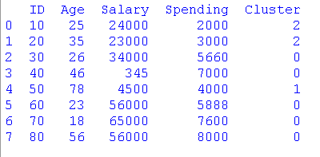
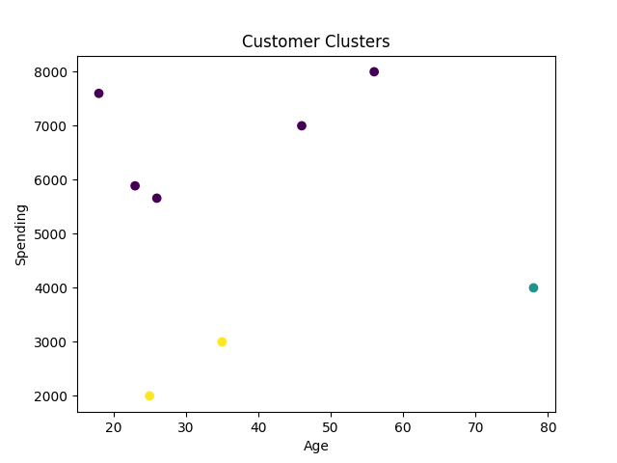

Program 3

Identify frequent item sets using the Apriori algorithm for a given transaction data set
Algorithm / Procedure
- Collect transaction dataset.
- Convert to one-hot encoding.
- Apply Apriori algorithm.
- Set minimum support (30%).
- Generate frequent itemsets.
- Derive association rules.

import pandas as pd
from mlxtend.frequent_patterns import apriori, association_rules

# Example transaction dataset
dataset = [
['Milk', 'Bread', 'Eggs'],
['Milk', 'Bread'],
['Milk', 'Eggs'],
['Bread', 'Eggs'],
['Milk', 'Bread', 'Eggs'],
['Milk', 'Bread', 'Butter'],
['Bread', 'Butter'], ['Butter', 'Eggs']
]

# Convert dataset into one-hot encoded DataFrame
from mlxtend.preprocessing import TransactionEncoder

te = TransactionEncoder()
te_data = te.fit(dataset).transform(dataset)
df = pd.DataFrame(te_data, columns=te.columns_)

print("Transaction Data (One-Hot Encoded):")
print(df)

# Apply Apriori algorithm (minimum support = 0.3 → 30%)
frequent_itemsets = apriori(df, min_support=0.3, use_colnames=True)

print("\nFrequent Itemsets:")
print(frequent_itemsets)

# Generate association rules (optional)
rules = association_rules(frequent_itemsets, metric="lift", min_threshold=1.0)

print("\nAssociation Rules:")
print(rules[['antecedents', 'consequents', 'support', 'confidence', 'lift']])

if not rules.empty:
best_rule = rules.loc[rules['confidence'].idxmax()]
print("\nRule with Maximum Confidence:")
print(f"IF {list(best_rule['antecedents'])} THEN {list(best_rule['consequents'])}")
print("Confidence:", best_rule['confidence'])

OUTPUT:

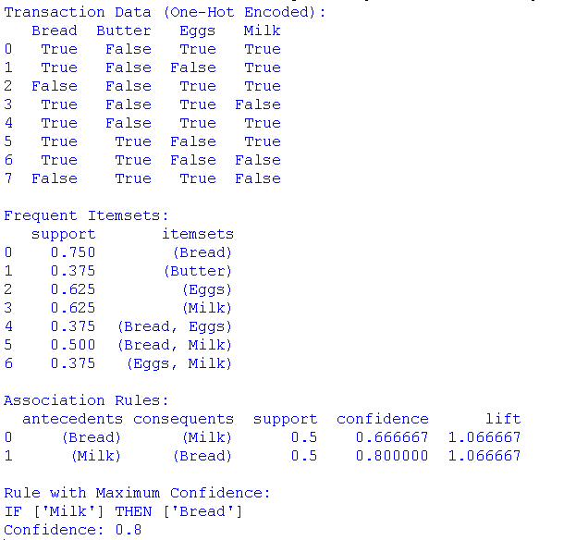

Program 4
Use a dataset of customer product reviews (e.g., Amazon reviews) to classify the sentiment of each review as positive, negative, or neutral using a pre-trained machine learning model (e.g., Naïve Bayes). Evaluate the accuracy of your sentiment classifier.

Algorithm / Procedure
- Load review dataset.
- Split into training/testing sets.
- Convert text to TF-IDF vectors.
- Train Naïve Bayes classifier.
- Predict sentiments.
- Evaluate accuracy.

import pandas as pd
from sklearn.model_selection import train_test_split
from sklearn.feature_extraction.text import TfidfVectorizer
from sklearn.naive_bayes import MultinomialNB
from sklearn.metrics import classification_report, accuracy_score

# Load dataset
file_path = r" /content/amazon_reviews_sample.csv

data = pd.read_csv(file_path)

df = pd.DataFrame(data)
print(df)

# Split data
x = df["review"]
y = df["sentiment"]
x_train, x_test, y_train, y_test = train_test_split(
x, y, test_size=0.3, random_state=42, stratify=y
)

# Vectorize text using TF-IDF
vectorizer = TfidfVectorizer()
x_train_vec = vectorizer.fit_transform(x_train)
x_test_vec = vectorizer.transform(x_test)

# Train Naïve Bayes classifier
model = MultinomialNB()
model.fit(x_train_vec, y_train)

# Evaluate
y_pred = model.predict(x_test_vec)
print("Accuracy:", accuracy_score(y_test, y_pred))
print("\nClassification Report:\n", classification_report(y_test, y_pred, zero_division=0))

# Test on new reviews
new_reviews = [
"This is the best chocolate I have ever eaten!",
"Not worth the price, very disappointed.",
"It was fine, but I've had better."
]
new_reviews_vec = vectorizer.transform(new_reviews)
predictions = model.predict(new_reviews_vec)

print("\nSample Predictions:")
for review, sentiment in zip(new_reviews, predictions):
print(f"Review: {review}\nPredicted Sentiment: {sentiment}\n")

OUTPUT:
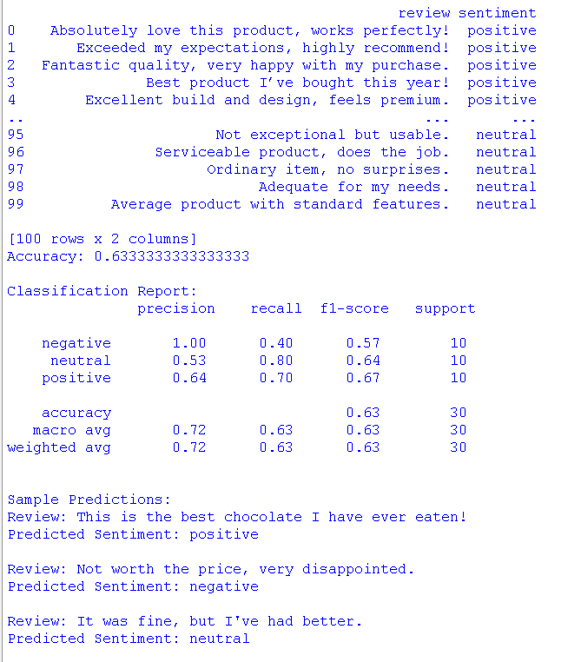

Program 5

Use text mining techniques to analyse a collection of news articles. Identify the most frequent terms and perform topic modelling using Latent Dirichlet Allocation (LDA) to find hidden topics within the articles.
Algorithm / Procedure
- Collect news articles.
- Preprocess text:
  - Remove stopwords
  - Tokenize
- Identify frequent terms.
- Generate word cloud.
- Apply LDA topic modeling.

!pip install gensim
import pandas as pd
import re
from sklearn.feature_extraction.text import ENGLISH_STOP_WORDS
from collections import Counter
from wordcloud import WordCloud
import matplotlib.pyplot as plt
from gensim import corpora, models

# Sample dataset
articles = [
"The stock market rallied today with tech shares leading the gains.",
"Political tensions are rising ahead of the national elections.",
"New research shows the benefits of a plant-based diet.",
"The sports team won their match in a thrilling last-minute comeback.",
"Scientists discover new species in the Amazon rainforest."
]
df = pd.DataFrame(articles, columns=['article'])

# Preprocess text
def preprocess(text):
text = re.sub(r'[^a-z\s]', '', text.lower())
return [w for w in text.split() if w not in ENGLISH_STOP_WORDS and len(w) > 2]

df['tokens'] = df['article'].apply(preprocess)

# Frequent terms
all_words = [w for t in df['tokens'] for w in t]
print("Most common words:", Counter(all_words).most_common(10))

# WordCloud
wordcloud_image = WordCloud(width=800, height=400, background_color='white').generate(" ".join(all_words))
plt.imshow(wordcloud_image, interpolation='bilinear')
plt.axis('off')
plt.show()

# Topic Modelling (LDA)
dictionary = corpora.Dictionary(df['tokens'])
corpus = [dictionary.doc2bow(t) for t in df['tokens']]
lda = models.LdaModel(corpus=corpus, id2word=dictionary, num_topics=3, random_state=42, passes=10)

for i, topic in lda.print_topics(num_words=5):
print(f"Topic {i}: {topic}")

OUTPUT:
